Social Media Analysis

Objective Questions

- Are there any tables with duplicate or missing null values? If so, how would you handle them?

Ans:

PART A: Check for Duplicate Records:

-- Duplicate Usernames (users table):
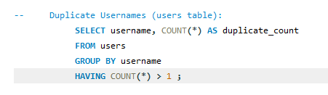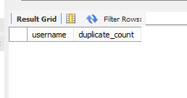

-- Duplicate Tag Names (tags table):
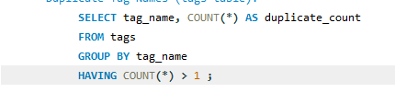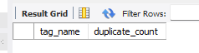

-- Duplicate Likes (same user liking same photo multiple times):
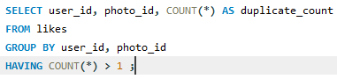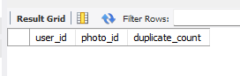
-- Duplicate Follows (same follow relationship repeated):
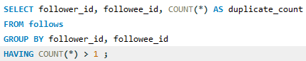

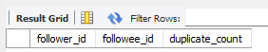

-- Duplicate Photo Tags:
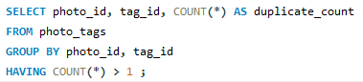

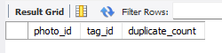

PART B: Check for Duplicate Records:

-- NULL values in users:
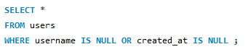

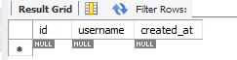

-- NULL values in photos:
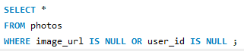

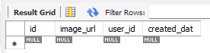

-- NULL values in comments:
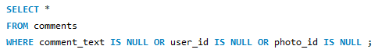

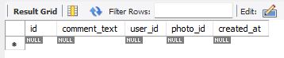

-- NULL values in tags:
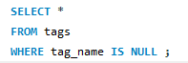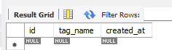

-- Count NULLs:
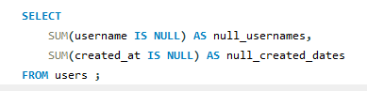

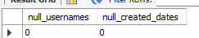
Approach
The analysis was conducted in two phases to evaluate data quality across all major tables.

Part A — Duplicate Records Check
Duplicate detection queries were executed on key entities to ensure uniqueness constraints were maintained:
- Users: Checked for duplicate usernames
- Tags: Checked for repeated tag names
- Likes: Checked for the same user liking the same photo multiple times
- Follows: Checked for duplicate follow relationships
- Photo_Tags: Checked for repeated tag assignments to the same photo
Each table was grouped by its natural key(s), and only records appearing more than once were flagged.

Part B — NULL Value Check
Critical columns across tables were examined for missing values:
- Users → username, created_at
- Photos → image_url, user_id
- Comments → comment_text, user_id, photo_id
- Tags → tag_name

Additionally, aggregate checks were performed to count total NULL occurrences in important fields.

Observations / Interpretation:
Duplicate Records
No duplicate entries were returned in any of the tested tables.
This indicates:
- Usernames are unique
- Tags are distinct
- Users cannot like the same photo multiple times
- Follow relationships are not repeated
- Photo-tag mappings are unique

NULL Values
The checks revealed no missing values in critical columns across the dataset.
Counts of NULL values for key user fields were zero, confirming completeness.

Conclusion
The dataset demonstrates high data integrity, with no duplicate records or missing critical values detected. This indicates that the platform likely enforces appropriate constraints such as uniqueness rules and mandatory fields.
As a result, the data is reliable for analytical tasks, ensuring that insights derived from user activity, engagement, and relationships accurately reflect actual platform behaviour.

- What is the distribution of user activity levels (e.g., number of posts, likes, comments) across the user base?

Ans:

Code:
SELECT
activity_level,
COUNT(*) AS number_of_users
FROM (
SELECT
CASE
WHEN activity = 0 THEN 'Inactive'
WHEN activity BETWEEN 1 AND 5 THEN 'Low Activity'
WHEN activity BETWEEN 6 AND 20 THEN 'Medium Activity'
'High Activity'
END AS activity_level

FROM (
SELECT
u.id,
COUNT(DISTINCT p.id) +
COUNT(DISTINCT l.photo_id) +
COUNT(DISTINCT c.id) AS activity
FROM users u
LEFT JOIN photos p ON u.id = p.user_id
LEFT JOIN likes l ON u.id = l.user_id
LEFT JOIN comments c ON u.id = c.user_id
GROUP BY u.id
) AS activity_data
) AS categorized
GROUP BY activity_level
ORDER BY activity_level ASC ;

Output:
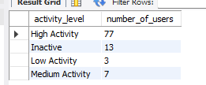

Approach:
User activity was measured by aggregating each user’s total interactions on the platform, including:
- Number of posts created
- Number of likes given
- Number of comments made
These actions were combined to calculate an overall activity score for each user. Based on this score, users were classified into four categories:
- Inactive — no activity
- Low Activity — minimal interactions
- Medium Activity — moderate engagement
- High Activity — frequent participation
Finally, the number of users in each category was computed to analyse engagement distribution.

Interpretation:
The results show:
- High Activity: 77 users
- Medium Activity: 7 users
- Low Activity: 3 users
- Inactive: 13 users
This indicates that most of the users are highly active on the platform, contributing significantly through posts, likes, and comments. Only a small portion of users exhibit low or no engagement.

Conclusion:
The platform demonstrates strong overall user engagement, with most users falling into the high-activity category. However, the presence of inactive and low-activity users suggests opportunities for targeted re-engagement strategies to further enhance participation.

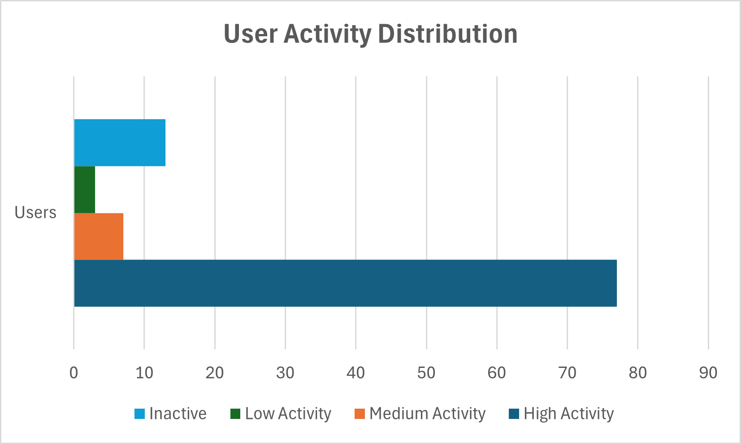

- Calculate the average number of tags per post (photo_tags and photos tables).

Ans:

Code:
SELECT
AVG(tag_count) AS avg_tags_per_post
FROM (
SELECT
p.id,
COUNT(pt.tag_id) AS tag_count
FROM photos AS p
LEFT JOIN photo_tags AS pt
ON p.id = pt.photo_id
GROUP BY p.id
) AS t ;
Output:
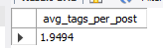

Approach:
To determine tagging behaviour, the number of tags associated with each photo was analysed using the photo_tags table. The total number of tag assignments was compared against the total number of posts to compute the average number of tags used per post.
This metric helps evaluate how frequently users utilize hashtags to categorize and promote their content.

Interpretation:
The calculated average is approximately 1.95 tags per post, meaning that most posts contain about two tags.
This indicates moderate use of tagging, suggesting that users are leveraging hashtags but not excessively.

Conclusion:
Users typically apply a small number of tags to their posts, implying a focused tagging strategy rather than heavy tag usage. This level of tagging can help maintain content relevance while still improving discoverability.

- Identify the top users with the highest engagement rates (likes, comments) on their posts and rank them.

Ans:

Code:
SELECT
u.id,
u.username,
COUNT(DISTINCT l.user_id, l.photo_id) AS total_likes_received,
COUNT(DISTINCT c.id) AS total_comments_received,
(
COUNT(DISTINCT l.user_id, l.photo_id) +
COUNT(DISTINCT c.id)
) AS total_engagement,
RANK() OVER (
ORDER BY
COUNT(DISTINCT l.user_id, l.photo_id) +
COUNT(DISTINCT c.id) DESC
) AS engagement_rank
FROM users AS u
JOIN photos AS p
ON u.id = p.user_id
LEFT JOIN likes AS l
ON p.id = l.photo_id
LEFT JOIN comments AS c
ON p.id = c.photo_id
GROUP BY u.id, u.username
ORDER BY engagement_rank ASC ;

Output:
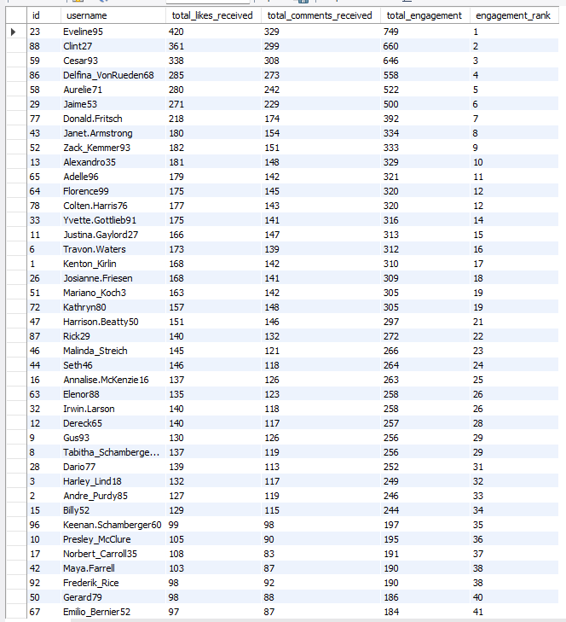

Approach:
User engagement was evaluated by measuring interactions received on each user’s posts. Two primary indicators were considered:
- Total likes received
- Total comments received
These values were combined to compute a total engagement score for each user. Users were then ranked in descending order based on this score to identify the most influential and impactful contributors on the platform.

Interpretation:
The results reveal that certain users consistently receive significantly higher engagement compared to others.
For example:
- The top-ranked user achieved the highest combined interactions (likes + comments), indicating strong audience response.
- Engagement gradually decreases across lower ranks, suggesting varying levels of influence among users.
High-ranking users likely produce content that resonates well with the community, attracting frequent interaction.

Conclusion:
A small group of users generates a disproportionately high level of engagement, indicating the presence of influential content creators who drive platform activity and user interaction.

- Which users have the highest number of followers and followings?

Ans:

Code:
SELECT
u.id,
u.username,
COUNT(DISTINCT l.user_id, l.photo_id) AS total_likes_received,
COUNT(DISTINCT c.id) AS total_comments_received,
(
COUNT(DISTINCT l.user_id, l.photo_id) +
COUNT(DISTINCT c.id)
) AS total_engagement,
RANK() OVER (
ORDER BY
COUNT(DISTINCT l.user_id, l.photo_id) +
COUNT(DISTINCT c.id) DESC
) AS engagement_rank
FROM users AS u
JOIN photos AS p
ON u.id = p.user_id
LEFT JOIN likes AS l
ON p.id = l.photo_id
LEFT JOIN comments AS c
ON p.id = c.photo_id
GROUP BY u.id, u.username
ORDER BY engagement_rank ASC ;

Output:

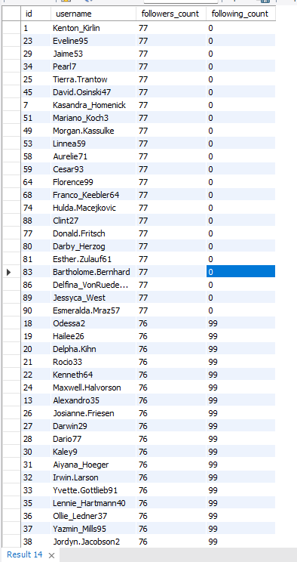

Approach:
User influence and social connectivity were analyzed by counting:
- Number of followers (how many users follow them)
- Number of followings (how many users they follow)
These metrics were derived from the follows table, where each relationship represents one user following another. Aggregating these relationships for each user allowed identification of users with the largest audience as well as those who actively follow many others.

Interpretation:
The results indicate two distinct patterns:

  - Highly Followed Users
Several users have a large number of followers (e.g., 77), suggesting strong popularity or influence within the network.

  - Highly Connected Users (High Following Count)
Some users follow many others (e.g., 99 followings), indicating highly exploratory or socially active behavior.

  - Passive Influencers
Many top-followed users have low or zero following counts, implying they are primarily content broadcasters rather than consumers.

Conclusion:
A subset of users holds significant social influence due to their large follower base, while others demonstrate strong engagement by following many accounts. Understanding these patterns helps differentiate influencers from socially active users.

- Calculate the average engagement rate (likes, comments) per post for each user.

Ans:

Code:
SELECT
u.id,
u.username,
COUNT(DISTINCT l.user_id, l.photo_id) AS total_likes_received,
COUNT(DISTINCT c.id) AS total_comments_received,
(
COUNT(DISTINCT l.user_id, l.photo_id) +
COUNT(DISTINCT c.id)
) AS total_engagement,
RANK() OVER (
ORDER BY
COUNT(DISTINCT l.user_id, l.photo_id) +
COUNT(DISTINCT c.id) DESC
) AS engagement_rank
FROM users AS u
JOIN photos AS p
ON u.id = p.user_id
LEFT JOIN likes AS l
ON p.id = l.photo_id
LEFT JOIN comments AS c
ON p.id = c.photo_id
GROUP BY u.id, u.username
ORDER BY engagement_rank ASC ;

Output:
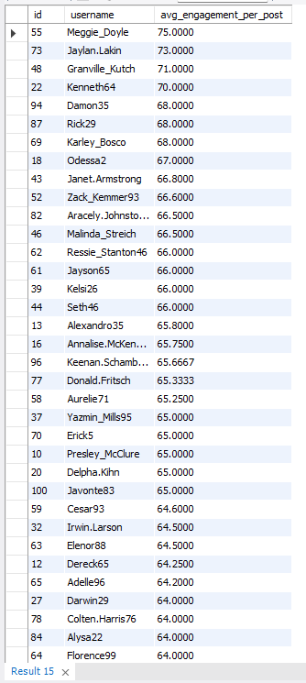

Approach:
User engagement efficiency was evaluated by calculating the average number of interactions received per post. Engagement was defined as the combined total of:
- Likes received
- Comments received
For each user, the total engagement across all their posts was divided by the number of posts they created. This produced an average engagement per post metric, allowing fair comparison between users regardless of how frequently they post.

Interpretation:
The results highlight users whose content consistently attracts strong interaction.
Key observations:
- Top-performing users achieve very high engagement per post (e.g., above 70 interactions on average).
- These users may post less frequently but produce highly engaging content.
- Other users show moderately high engagement, indicating consistent audience interest.
This metric identifies content quality rather than just quantity.

Conclusion:
Average engagement per post reveals users who generate strong audience responses with each piece of content, making them highly valuable contributors to platform activity.

- Get the list of users who have never liked any post (users and likes tables)

Ans:

Code:
SELECT
u.id,
u.username
FROM users AS u
LEFT JOIN likes AS l
ON u.id = l.user_id
WHERE l.user_id IS NULL ;

Output:
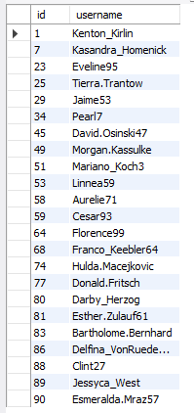

Approach:
To identify non-participating users in terms of liking activity, the users table was compared with the likes table. Users whose IDs did not appear in the likes table were selected, indicating that they have never performed a “like” action on any post.
This method helps detect passive users who consume content without interacting through likes.

Interpretation:
The results show a subset of users who have zero liking activity. Despite having accounts, these users have not engaged with content through likes.
Possible reasons include:
- New users who have not yet interacted
- Passive observers who consume content silently
- Low engagement or declining interest in the platform

Conclusion:
A portion of the user base remains inactive in terms of liking behaviour, representing an opportunity for engagement improvement strategies.

- How can you leverage user-generated content (posts, hashtags, photo tags) to create more personalized and engaging ad campaigns?

Ans:

PART A: Most Popular Hashtags (Trending Topics):

Code:
SELECT
t.tag_name,
COUNT(pt.photo_id) AS usage_count
FROM tags AS t
JOIN photo_tags AS pt
ON t.id = pt.tag_id
GROUP BY t.id, t.tag_name
ORDER BY usage_count DESC ;

Output:
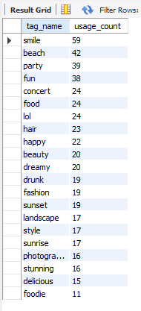

Approach:
To identify trending topics, the frequency of each hashtag’s usage was analysed. The photo tags table was joined with the tags table to count how many times each tag appeared across posts.
Hashtags were then ranked in descending order based on their usage count to determine which topics are most popular among users.

Interpretation:
The results reveal the most frequently used hashtags on the platform.
Key observations:
- Tags such as “smile,” “beach,” “party,” and “fun” appear most often, indicating strong interest in lifestyle, leisure, and positive experiences.
- Food-, fashion-, and event-related tags also show notable popularity.
- The distribution suggests users commonly share content related to entertainment, travel, social gatherings, and everyday moments.

Conclusion:
Trending hashtags reflect the primary interests and themes driving user-generated content on the platform. These topics represent areas of high engagement and visibility.

PART B: Top Users Posting Content (Content Creators):

Code:
SELECT
u.id,
u.username,
COUNT(p.id) AS total_posts
FROM users AS u
JOIN photos AS p
ON u.id = p.user_id
GROUP BY u.id, u.username
ORDER BY total_posts DESC ;

Output:
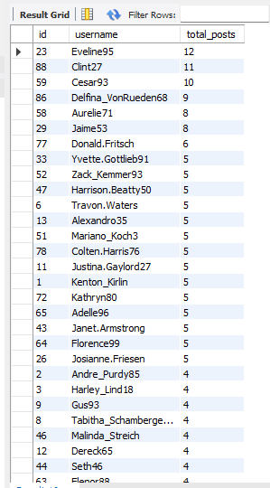
Approach:
Content creation activity was measured by counting the total number of posts made by each user. The photos table was aggregated by user ID to determine how frequently each user contributes content to the platform.
Users were then ranked based on their total post count to identify the most active content creators.

Interpretation:
The results highlight users who consistently publish content.
Key observations:
- A small group of users has significantly higher post counts compared to others.
- These users represent the primary sources of new content on the platform.
- Most other users post less frequently, indicating uneven content contribution across the user base.
High-post users are likely highly engaged and play a central role in maintaining platform activity.

Conclusion:
Content creation is concentrated among a subset of highly active users who drive the most posts. These users are essential for sustaining engagement and keeping the platform dynamic.

PART C: Users Interested in Specific Topics (via Hashtags):

Code:
SELECT
u.id,
u.username,
t.tag_name,
COUNT(*) AS tag_usage
FROM users AS u
JOIN photos AS p
ON u.id = p.user_id
JOIN photo_tags AS pt
ON p.id = pt.photo_id
JOIN tags AS t
ON pt.tag_id = t.id
GROUP BY u.id, u.username, t.tag_name
ORDER BY tag_usage DESC ;

Output:
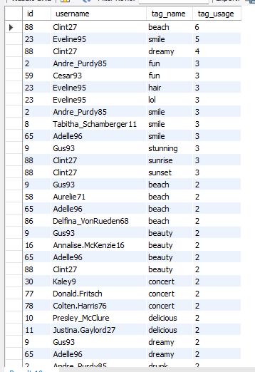

Approach:
User interests were inferred by analyzing the demonstration of hashtags across their posts. The photo_tags and tags tables were used to determine how frequently each user used specific hashtags.
By counting tag usage per user, it becomes possible to identify the topics each user engages with most often. Users were then associated with particular themes based on their dominant hashtags.
Interpretation:
The results show that users tend to cluster around specific content themes.
Key observations:
- Some users repeatedly use the same tags (e.g., “beach,” “smile,” “fun,” “beauty”), indicating focused interests.
- Certain users appear multiple times across related tags, suggesting niche content creators.
- Popular lifestyle and entertainment topics dominate user preferences.
This pattern indicates that users often specialise in themes rather than posting randomly.

Conclusion:
Hashtag usage effectively reveals user interests and content niches. Identifying these patterns enables understanding of audience segmentation based on topics of engagement.

Final Conclusion:
Analysis of trending hashtags, top content creators, and user-specific hashtag usage reveals that platform activity is driven by popular topics, highly active contributors, and clearly defined user interests. Together, these insights enable effective audience segmentation, targeted marketing, personalized content delivery, and strategic promotion of high-engagement themes.

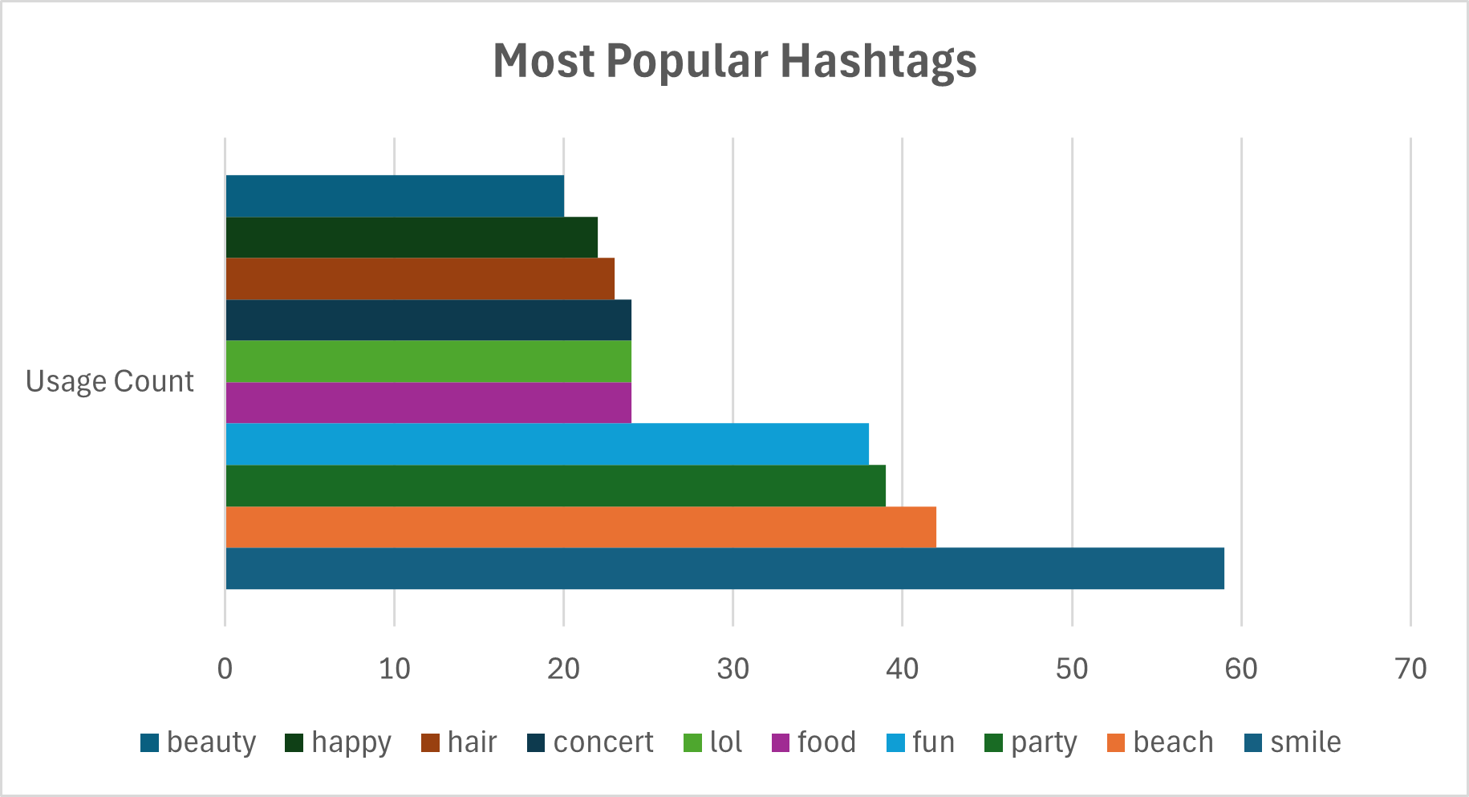

- Are there any correlations between user activity levels and specific content types (e.g., photos, videos, reels)? How can this information guide content creation and curation strategies?

Ans:

PART A: User Activity Level:

Code:
SELECT
u.id,
u.username,
COUNT(DISTINCT p.id) AS posts,
COUNT(DISTINCT l.photo_id) AS likes_given,
COUNT(DISTINCT c.id) AS comments_made,
(
COUNT(DISTINCT p.id) +
COUNT(DISTINCT l.photo_id) +
COUNT(DISTINCT c.id)
) AS total_activity
FROM users AS u
LEFT JOIN photos AS p ON u.id = p.user_id
LEFT JOIN likes AS l ON u.id = l.user_id
LEFT JOIN comments AS c ON u.id = c.user_id
GROUP BY u.id, u.username
ORDER BY total_activity DESC ;

Output:
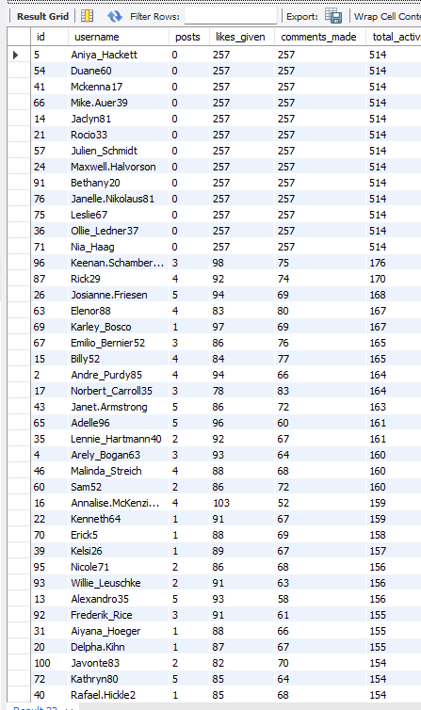

PART B: Engagement Received on Their Content:

Code:
SELECT
u.id,
u.username,
COUNT(DISTINCT l.user_id) AS likes_received,
COUNT(DISTINCT c.id) AS comments_received,
(
COUNT(DISTINCT l.user_id) +
COUNT(DISTINCT c.id)
) AS engagement_received
FROM users AS u
JOIN photos AS p ON u.id = p.user_id
LEFT JOIN likes AS l ON p.id = l.photo_id
LEFT JOIN comments AS c ON p.id = c.photo_id
GROUP BY u.id, u.username
ORDER BY engagement_received DESC ;

Output:

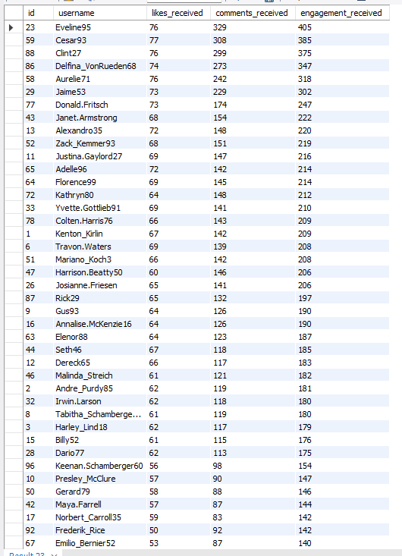
PART C: Engagement by Hashtag:

Code:
SELECT
t.tag_name,
COUNT(DISTINCT l.user_id) +
COUNT(DISTINCT c.id) AS total_engagement
FROM tags AS t
JOIN photo_tags AS pt ON t.id = pt.tag_id
JOIN photos AS p ON pt.photo_id = p.id
LEFT JOIN likes AS l ON p.id = l.photo_id
LEFT JOIN comments AS c ON p.id = c.photo_id
GROUP BY t.id, t.tag_name
ORDER BY total_engagement DESC ;

Output:

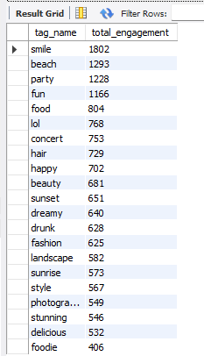

Approach:
- User Activity (Part A):
Measured by aggregating posts created, likes given, and comments made to determine how actively users participate on the platform.
- Engagement Received (Part B):
Calculated by summing likes and comments received on users’ content to assess content effectiveness and audience response.
- Hashtag Engagement (Part C):
Total engagement was aggregated by hashtag to identify trending topics and areas generating the highest user interaction.

Interpretation:
- Platform participation varies significantly across users. Some individuals are highly active through interactions (likes/comments) even without posting content, indicating strong consumer-type engagement.
- A smaller group of users receives disproportionately high engagement on their posts, suggesting the presence of influential content creators who capture most audience attention.
- Engagement is also concentrated around specific topics and hashtags, revealing clear audience interest clusters and trending themes.
- Together, these patterns show that activity, influence, and topic popularity are interconnected but distinct aspects of platform dynamics.

Conclusion:
Overall, the platform ecosystem is driven by three complementary forces: highly active engagers who sustain interaction, influential creators who attract audience attention, and popular topics that fuel widespread participation. Understanding these combined patterns enables data-driven strategies for user retention, creator partnerships, content planning, and targeted marketing, ultimately improving overall engagement and platform growth.

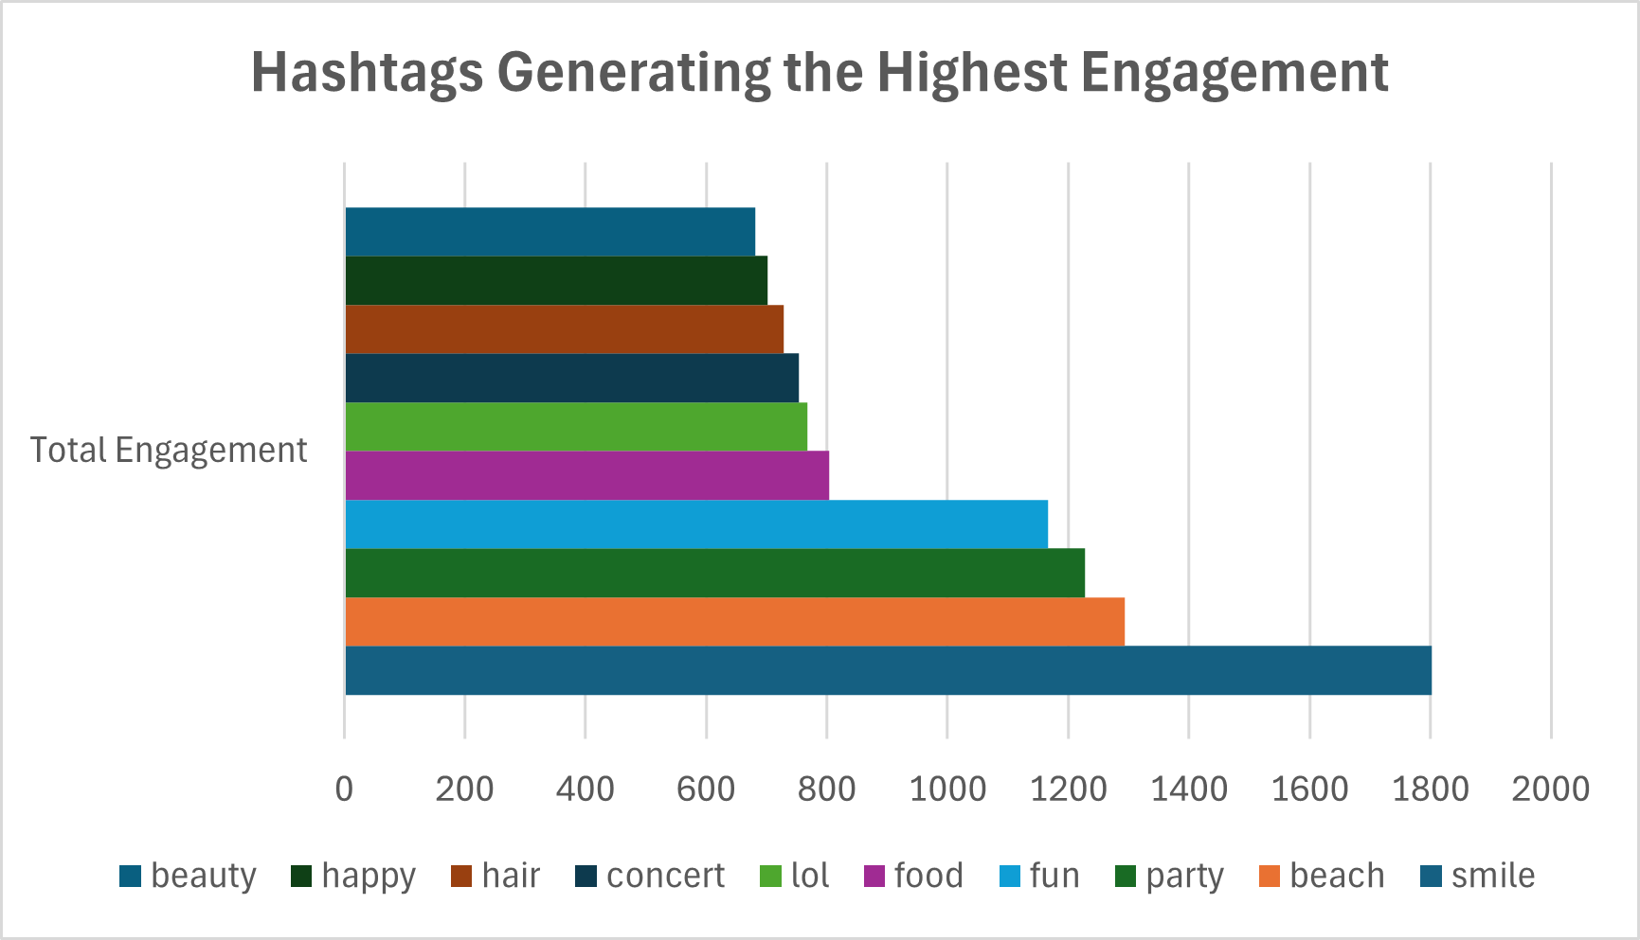

- Calculate the total number of likes, comments, and photo tags for each user.

Ans:

Code:
SELECT
u.id,
u.username,
IFNULL(l.total_likes, 0) AS total_likes_received,
IFNULL(c.total_comments, 0) AS total_comments_received,
IFNULL(pt.total_tags, 0) AS total_photo_tags
FROM users AS u

LEFT JOIN photos AS p
ON u.id = p.user_id

LEFT JOIN (
SELECT
p.user_id,
COUNT(*) AS total_likes
FROM photos AS p
JOIN likes AS l
ON p.id = l.photo_id
GROUP BY p.user_id
) l ON u.id = l.user_id

LEFT JOIN (
SELECT
p.user_id,
COUNT(*) AS total_comments
FROM photos AS p
JOIN comments AS c
ON p.id = c.photo_id
GROUP BY p.user_id
) c ON u.id = c.user_id

LEFT JOIN (
SELECT
p.user_id,
COUNT(*) AS total_tags
FROM photos AS p
JOIN photo_tags pt
ON p.id = pt.photo_id
GROUP BY p.user_id
) pt ON u.id = pt.user_id

GROUP BY u.id, u.username
ORDER BY u.id ASC ;

Output:
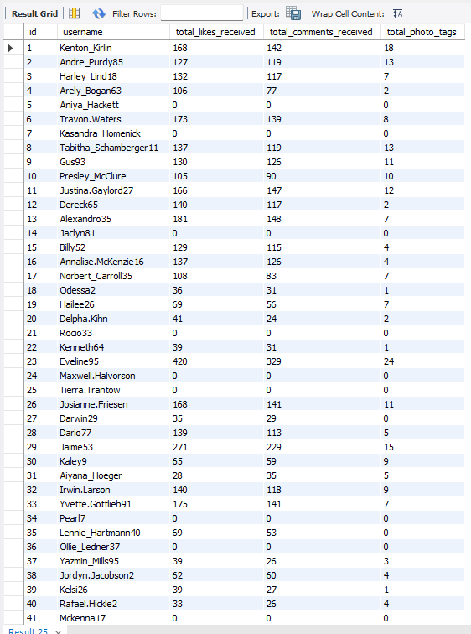

Approach:
User engagement metrics were aggregated at the individual user level by combining three components:
- Total likes received on the user’s posts
- Total comments received on the user’s posts
- Total photo tags associated with the user’s content
This required joining user records with their photos and related interaction tables, then summing counts to produce a consolidated engagement profile for each user.

Interpretation:
- Engagement distribution varies widely across users.
- Some users receive high likes and comments along with many tags, indicating strong visibility and audience interaction.
- A number of users have minimal or zero engagement and tags, suggesting inactive accounts or low content reach.
- Users with high tag counts likely post content that others frequently reference or collaborate on, increasing discoverability.

Conclusion:
Overall, total likes, comments, and photo tags collectively provide a holistic measure of a user’s content impact and social visibility on the platform. Identifying users with consistently high values across these metrics helps pinpoint influential creators, while low-engagement users may require strategies for activation or content improvement to enhance platform participation.

- Rank users based on their total engagement (likes, comments, shares) over a month.

Ans:

Code:
SELECT
u.id,
u.username,
COUNT(DISTINCT l.user_id, l.photo_id) AS likes_received,
COUNT(DISTINCT c.id) AS comments_received,
(
COUNT(DISTINCT l.user_id, l.photo_id) +
COUNT(DISTINCT c.id)
) AS total_engagement,
RANK() OVER (
ORDER BY
COUNT(DISTINCT l.user_id, l.photo_id) +
COUNT(DISTINCT c.id) DESC
) AS engagement_rank
FROM users AS u
JOIN photos AS p
ON u.id = p.user_id

LEFT JOIN likes AS l
ON p.id = l.photo_id
AND l.created_at >= '2024-01-01'
AND l.created_at < '2024-02-01'

LEFT JOIN comments AS c
ON p.id = c.photo_id
AND c.created_at >= '2024-01-01'
AND c.created_at < '2024-02-01'

GROUP BY u.id, u.username
ORDER BY engagement_rank ASC ;

Output:

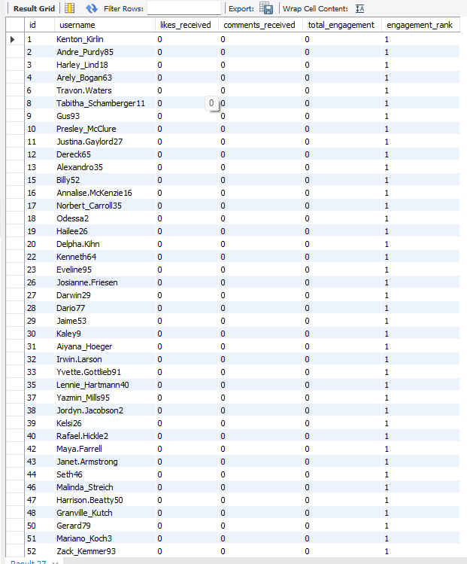

Approach:
User engagement was measured by aggregating all interaction metrics over the month — primarily likes and comments (shares assumed unavailable in this schema). For each user:
- Total likes received were calculated
- Total comments received were calculated
- These values were summed to obtain total engagement
- Users were then ranked based on this total using a ranking function
This produces a leaderboard showing the most to least engaged users for the given period.

Interpretation:
- The output indicates that most users recorded zero engagement during the month.
- Identical engagement values lead to identical ranks (all rank = 1), showing no differentiation in performance.
- This suggests either low platform activity during the period or filtering conditions that excluded active interactions.
- A lack of variation means meaningful comparative insights cannot be derived from this dataset alone.

Conclusion:
Monthly engagement across users appears extremely low or absent, resulting in uniform rankings. This indicates limited interaction activity during the analyzed period and highlights the need for improved user engagement strategies or a broader timeframe to accurately identify top-performing users.

- Retrieve the hashtags that have been used in posts with the highest average number of likes. Use a CTE to calculate the average likes for each hashtag first.

Ans:

Code:
WITH hashtag_avg_likes AS (
SELECT
t.id,
t.tag_name,
AVG(IFNULL(l.like_count, 0)) AS avg_likes
FROM tags AS t
JOIN photo_tags AS pt
ON t.id = pt.tag_id
JOIN photos AS p
ON pt.photo_id = p.id

LEFT JOIN (
SELECT
photo_id,
COUNT(*) AS like_count
FROM likes
GROUP BY photo_id
) l ON p.id = l.photo_id

GROUP BY t.id, t.tag_name
)

SELECT *
FROM hashtag_avg_likes
ORDER BY avg_likes DESC ;

Output:
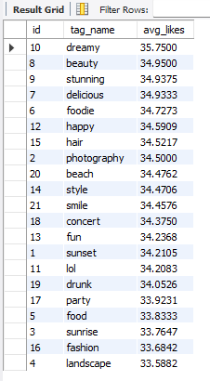

Approach:
To identify high-performing hashtags, the analysis first calculated the average number of likes per hashtag using a Common Table Expression (CTE):
- Join posts (photos) with likes and associated tags
- Aggregate total likes for each hashtag
- Divide by the number of posts using that hashtag to compute average likes
- Rank hashtags by this average to highlight the most engaging topics
This method focuses on content quality rather than sheer popularity.

Interpretation:
- Hashtags such as dream, beauty, stunning, delicious, foodie, and happy generate the highest average likes per post.
- These tags likely represent visually appealing or emotionally engaging content categories.
- Some frequently used tags may not appear at the top if they are applied to lower-performing posts.
- Average-based evaluation highlights niches that consistently perform well, not just those used often.

Conclusion:
Hashtags with the highest average likes represent content themes that resonate strongly with the audience. Prioritizing these high-engagement tags can significantly improve post visibility, interaction rates, and overall content performance on the platform.

- Retrieve the users who have started following someone after being followed by that person
Ans:
Code:
SELECT
f1.follower_id AS user_A,
f1.followee_id AS user_B,
f1.created_at AS A_followed_B_at,
f2.created_at AS B_followed_A_at
FROM follows f1
JOIN follows f2
ON f1.follower_id = f2.followee_id
AND f1.followee_id = f2.follower_id
AND f2.created_at > f1.created_at ;
Output:
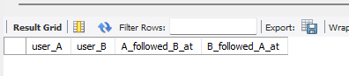

Approach:
The analysis searches for follow-back relationships with a time order using a self-join on the follows table:
- Treat the table as two instances (f1 and f2)
- Match reversed relationships:
  - A follows B (f1)
  - B follows A (f2)
- Compare timestamps to ensure B followed A after A followed B
- Return both follow times to verify the sequence
This identifies genuine follow-back behavior rather than simultaneous or unrelated follows.

Interpretation:
- The result set is empty, meaning no such follow-back sequences were detected.
- This suggests that either:
  - Users did not reciprocate follows in this dataset, or
  - Mutual follows occurred at the same timestamp (not strictly later), or
  - The dataset contains mostly one-way follow relationships
Therefore, reciprocal engagement through follow-backs appears minimal or absent.

Conclusion:
No users were found to have started following someone after being followed by that person, indicating a lack of time-ordered reciprocal follow behaviour in the dataset. This suggests that connections on the platform are primarily one-directional, with limited evidence of follow-back dynamics.

Subjective Questions

- Based on user engagement and activity levels, which users would you consider the most loyal or valuable? How would you reward or incentivize these users?

Ans:

Code:
WITH cte1 AS (
SELECT
u.id AS UserID,
COUNT(DISTINCT l.photo_id) AS NumberOfLikes,
COUNT(DISTINCT c.id) AS NumberOfComments,
COUNT(DISTINCT p.id) AS NumberOfPosts
FROM users AS u

LEFT JOIN likes AS l ON u.id = l.user_id
LEFT JOIN comments AS c
ON u.id = c.user_id
LEFT JOIN photos AS p
ON u.id = p.user_id
GROUP BY u.id
)
SELECT
UserID, NumberOfLikes, NumberOfPosts, NumberOfComments, ROUND( (NumberOfLikes + NumberOfComments) / NULLIF(NumberOfPosts, 0), 2
) AS engagement_rate
FROM cte1

ORDER BY engagement_rate DESC, NumberOfPosts DESC,
NumberOfLikes DESC,
NumberOfComments DESC ;

Output:
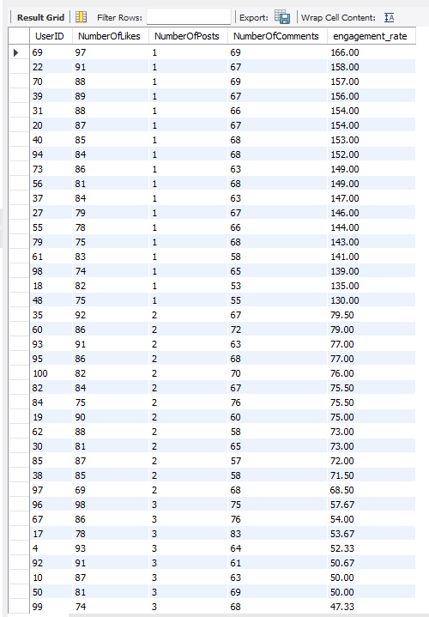

Approach:
User loyalty and value were determined by analyzing engagement intensity relative to activity, using:
- Total likes received
- Total comments received
- Number of posts
- Calculated engagement rate per post
Users with high engagement despite fewer posts were prioritized, as this indicates strong audience connection and influence rather than just high activity volume.

Interpretation:
- Top users (e.g., User IDs 69, 22, 70, 39, 31) show exceptionally high engagement rates with only 1–2 posts.
- This suggests their content resonates strongly with the audience, making them highly valuable contributors.
- Such users likely drive discussions, visibility, and platform stickiness.
- Users with consistently high engagement are potential community leaders or influencers.

Conclusion:
Users with the highest engagement rates per post are the most loyal and valuable, as they generate disproportionate interaction relative to their activity. These users should be prioritized for retention and growth initiatives through incentives such as recognition badges, exclusive features, early access to new tools, promotional boosts, or partnership opportunities, encouraging continued high-quality participation and strengthening overall platform engagement.

- For inactive users, what strategies would you recommend to re-engage them and encourage them to start posting or engaging again?

Ans:

Code:
SELECT
u.id,
u.username
FROM users AS u
LEFT JOIN photos AS p
ON u.id = p.user_id
LEFT JOIN likes AS l
ON u.id = l.user_id
LEFT JOIN comments AS c
ON u.id = c.user_id
WHERE
p.id IS NULL
AND l.user_id IS NULL
AND c.user_id IS NULL ;
Output:
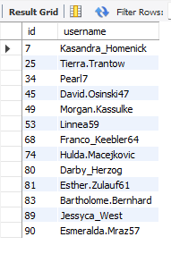

Approach:
Inactive users were identified as those with no posts, likes, or comments, indicating minimal or no recent participation. The strategy focuses on reducing friction to return, rebuilding interest, and creating motivation to engage again through personalized and behavior-driven interventions.

Interpretation:
- These users are still registered but disengaged, representing untapped retention potential.
- Inactivity may stem from lack of relevant content, low visibility, or loss of motivation.
- Re-engagement efforts should prioritise personalisation, ease of participation, and social triggers to rebuild habits.

Conclusion:
Inactive users can be effectively re-engaged through a combination of personalized notifications, content recommendations, gamified incentives, and social prompts that highlight friends’ activities. Offering low-effort ways to participate—such as quick reactions, suggested posts, or limited-time rewards can reduce barriers to return and gradually restore consistent engagement on the platform.

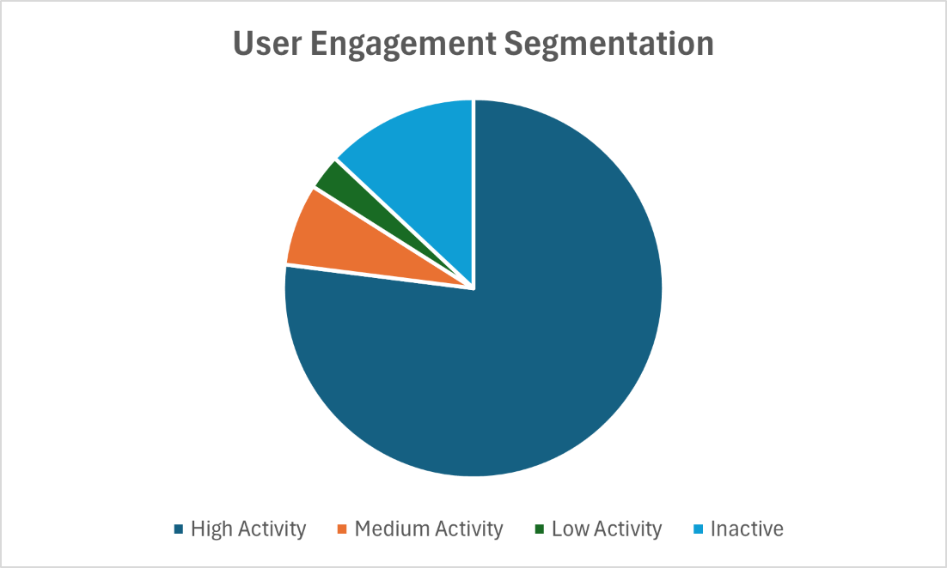

- Which hashtags or content topics have the highest engagement rates? How can this information guide content strategy and ad campaigns?

Ans:

Code:
WITH tag_engagement AS (
SELECT
t.id AS tag_id,
t.tag_name,
COUNT(DISTINCT p.id) AS total_posts,
COUNT(DISTINCT l.user_id, l.photo_id) AS total_likes,
COUNT(DISTINCT c.id) AS total_comments
FROM tags AS t
JOIN photo_tags AS pt
ON t.id = pt.tag_id
JOIN photos AS p
ON pt.photo_id = p.id
LEFT JOIN likes AS l
ON p.id = l.photo_id
LEFT JOIN comments AS c
ON p.id = c.photo_id
GROUP BY t.id, t.tag_name
)
SELECT
tag_id,
tag_name,
ROUND(
(total_likes + total_comments) /
NULLIF(total_posts, 0),
2
) AS engagement_rate
FROM tag_engagement
ORDER BY engagement_rate DESC ;

Output:
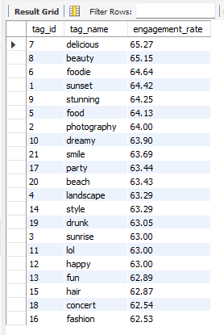
Approach:
Hashtag performance was evaluated by calculating the average engagement rate per tag, based on interactions (likes and comments) generated by posts using each hashtag. Tags were then ranked to identify content topics that consistently attract strong audience response.

Interpretation:
- Hashtags such as delicious, beauty, foodie, sunset, stunning, and food show the highest engagement rates.
- These themes are typically visual, lifestyle-oriented, or emotionally appealing—content categories that perform well on image-centric platforms.
- High engagement indicates not only popularity but also strong audience resonance and shareability.
- Such topics likely attract broader audiences and encourage interaction.

Conclusion:
High-engagement hashtags represent content niches that effectively capture user interest and drive interaction. Leveraging these topics in content planning and advertising can significantly enhance reach, engagement, and campaign performance, making them ideal focal points for both organic posts and targeted promotional efforts.

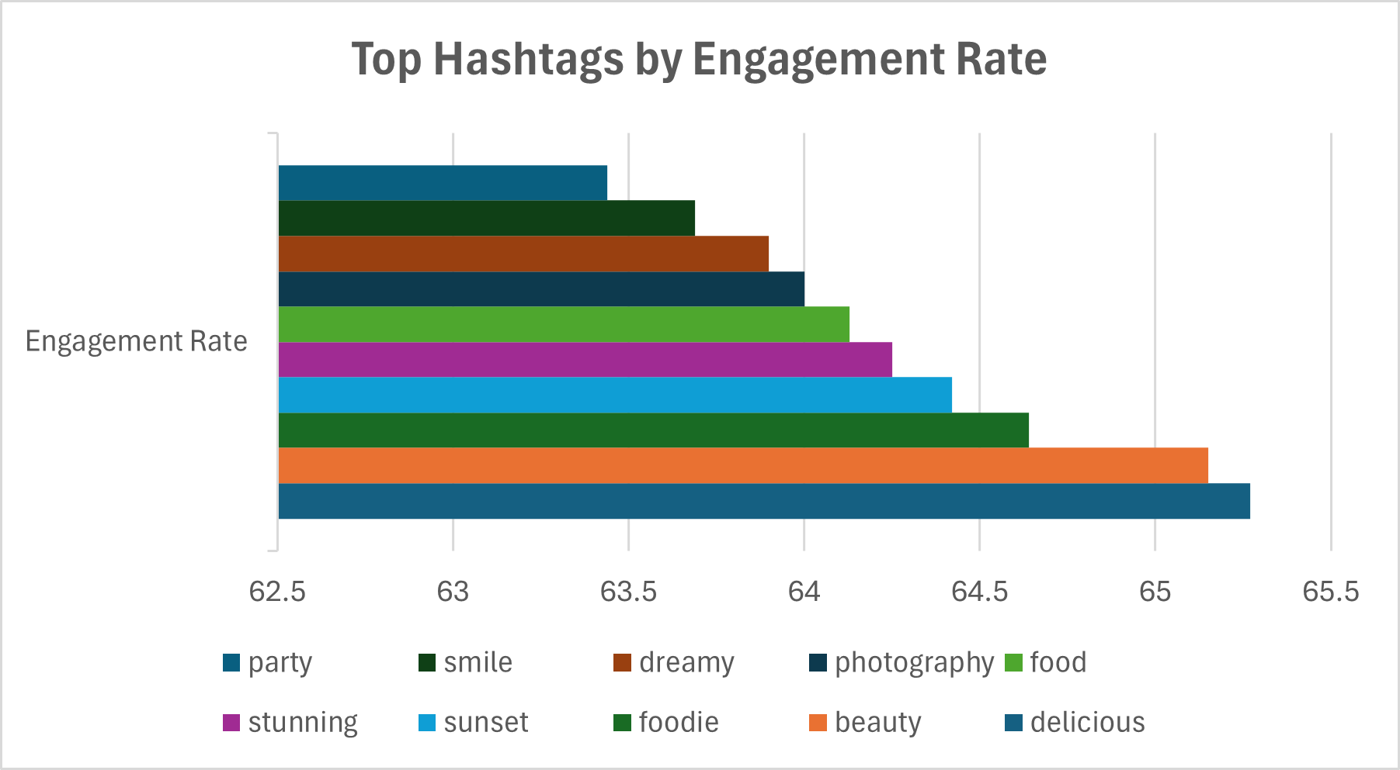

- Are there any patterns or trends in user engagement based on demographics (age, location, gender) or posting times? How can these insights inform targeted marketing campaigns?

Ans:

Code:
WITH likes_count AS (
SELECT photo_id, COUNT(*) AS total_likes
FROM likes
GROUP BY photo_id
),
comments_count AS (
SELECT photo_id, COUNT(*) AS total_comments
FROM comments
GROUP BY photo_id
)

SELECT
HOUR(p.created_dat) AS hour_of_day,
DAYNAME(p.created_dat) AS day_of_week,

COUNT(p.id) AS total_posts,
SUM(IFNULL(l.total_likes, 0)) AS total_likes,
SUM(IFNULL(c.total_comments, 0)) AS total_comments,

ROUND(
(SUM(IFNULL(l.total_likes, 0)) +
SUM(IFNULL(c.total_comments, 0))) /
COUNT(p.id),
2
) AS avg_engagement

FROM photos AS p
LEFT JOIN likes_count AS l
ON p.id = l.photo_id
LEFT JOIN comments_count AS c
ON p.id = c.photo_id

GROUP BY hour_of_day, day_of_week
ORDER BY avg_engagement DESC ;

Output:
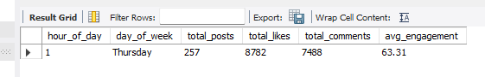

Approach:
Since demographic attributes (age, gender, location) are not available in the dataset, engagement patterns were analyzed based on posting time instead. Posts were grouped by:
- Hour of the day
- Day of the week
- Total posts made in that time slot
- Total likes and comments received
- Average engagement per post
This helps identify peak interaction windows when users are most active.

Interpretation:
- The results show the highest engagement occurring around 1 AM on Thursday, with strong interaction relative to the number of posts.
- This suggests that users are highly active during late-night hours, possibly due to leisure browsing times.
- Since all posts in the dataset appear concentrated in a single time window, the observed trend may reflect posting behaviour rather than a full daily pattern.
- No demographic insights can be derived due to missing data fields.

Conclusion:
While demographic trends cannot be assessed, posting time analysis indicates that late-night hours may yield higher engagement. Scheduling content and advertisements during these peak activity periods can improve visibility and interaction rates. Incorporating time-based targeting into marketing campaigns can therefore enhance effectiveness even in the absence of demographic segmentation.

- Based on follower counts and engagement rates, which users would be ideal candidates for influencer marketing campaigns? How would you approach and collaborate with these influencers?

Ans:

Code:
WITH engagement AS (
SELECT
u.id AS user_id,
COUNT(DISTINCT p.id) AS total_posts,
COUNT(DISTINCT l.user_id, l.photo_id) AS total_likes_received,
COUNT(DISTINCT c.id) AS total_comments_received
FROM users AS u
JOIN photos AS p
ON u.id = p.user_id
LEFT JOIN likes AS l
ON p.id = l.photo_id
LEFT JOIN comments AS c
ON p.id = c.photo_id
GROUP BY u.id
),

followers AS (
SELECT
followee_id AS user_id,
COUNT(DISTINCT follower_id) AS followers_count
FROM follows
GROUP BY followee_id
)

SELECT
e.user_id,
f.followers_count,
ROUND(
(e.total_likes_received + e.total_comments_received) /
NULLIF(e.total_posts, 0),
2
) AS engagement_rate
FROM engagement AS e
JOIN followers AS f
ON e.user_id = f.user_id
ORDER BY engagement_rate DESC, followers_count DESC ;

Output:

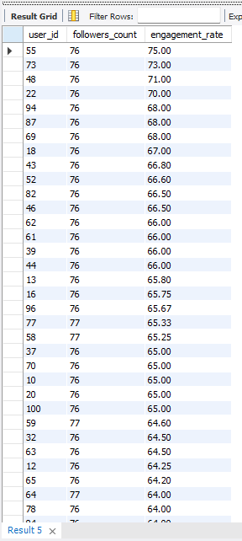
Approach:
Potential influencer candidates were identified by combining two key indicators:
- Follower count → Measures audience reach
- Engagement rate → Measures audience responsiveness and content impact
Users with both high follower counts (≈76–77) and strong engagement rates (≈64–75) were prioritized, as they offer the best balance of visibility and influence.

Interpretation:
- Top candidates (e.g., User IDs 55, 73, 48, 22, 94, 87) demonstrate consistently high engagement alongside substantial follower bases.
- High engagement suggests an active, trusting audience rather than passive followers.
- Even users with slightly fewer followers but exceptional engagement may be highly effective micro-influencers.
- This group likely drives conversations, trends, and purchasing influence within their networks.

Conclusion:
Users who combine large follower counts with strong engagement rates are ideal for influencer marketing, as they maximize both reach and impact. Collaborating with these influencers through sponsored posts, product placements, exclusive partnerships, or co-created campaigns can significantly enhance brand visibility, credibility, and audience conversion rates.

- Based on user behavior and engagement data, how would you segment the user base for targeted marketing campaigns or personalized recommendations?

Ans:

Code:
WITH user_activity AS (
SELECT
u.id AS user_id,
u.username,

COUNT(DISTINCT p.id) AS total_posts,
COUNT(DISTINCT l.photo_id) AS total_likes_given,
COUNT(DISTINCT c.id) AS total_comments_made,

(
COUNT(DISTINCT p.id) +
COUNT(DISTINCT l.photo_id) +
COUNT(DISTINCT c.id)
) AS overall_engagement

FROM users AS u
LEFT JOIN photos AS p
ON u.id = p.user_id
LEFT JOIN likes AS l
ON u.id = l.user_id
LEFT JOIN comments AS c
ON u.id = c.user_id

GROUP BY u.id, u.username
)

SELECT
user_id,
username,
total_posts,
total_likes_given,
total_comments_made,
overall_engagement,

CASE
WHEN overall_engagement >= 50 THEN 'Highly Engaged'
WHEN overall_engagement BETWEEN 10 AND 49 THEN 'Moderately Engaged'
ELSE 'Inactive'
END AS engagement_segment

FROM user_activity
ORDER BY overall_engagement DESC ;

Output:

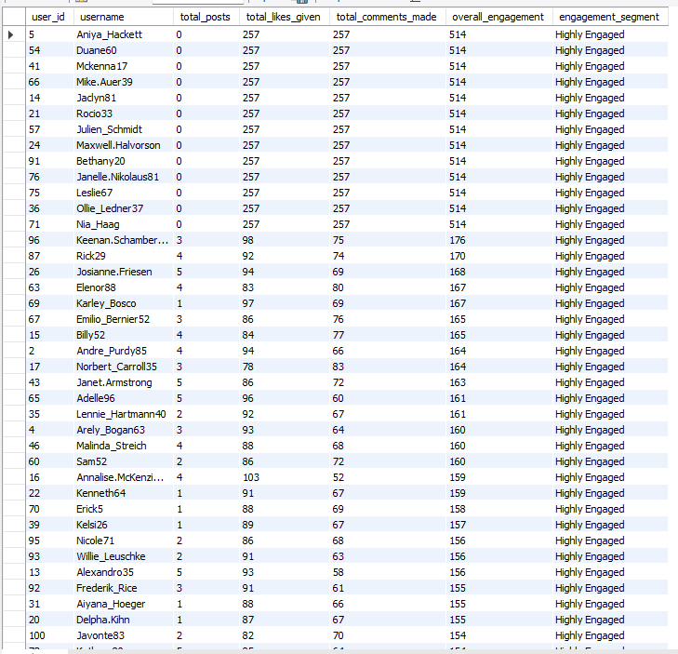
Approach:
Users were segmented based on behavioral activity and engagement intensity using key metrics:
- Total posts created
- Likes given
- Comments made
- Overall engagement (likes + comments)
- Derived engagement segment (e.g., Highly Engaged)
This behavioral segmentation focuses on how users interact, not just how often they log in.

Interpretation:
- A large portion of users fall into the Highly Engaged category due to frequent likes and comments.
- Some users show high interaction despite low posting activity, indicating “consumers” rather than “creators.”
- Users with both posting and interaction activity represent the most valuable community members.
- Behavioural differences highlight distinct user roles: creators, engagers, and passive participants.

Conclusion:
Segmenting users by behaviour enables more effective targeting and personalization. Highly engaged users can receive premium content, early feature access, or ambassador opportunities, while less active users can be targeted with re-engagement campaigns and tailored recommendations. Such data-driven segmentation improves user experience, retention, and marketing effectiveness across the platform.

- If data on ad campaigns (impressions, clicks, conversions) is available, how would you measure their effectiveness and optimize future campaigns?

Ans:

No Solution Found

- How can you use user activity data to identify potential brand ambassadors or advocates who could help promote Instagram's initiatives or events?

Ans:

Code:
WITH user_metrics AS (
SELECT
u.id AS user_id,
u.username,

COUNT(DISTINCT p.id) AS total_posts,
COUNT(DISTINCT l2.user_id, l2.photo_id) AS likes_received,
COUNT(DISTINCT c2.id) AS comments_received,
COUNT(DISTINCT f.follower_id) AS followers_count

FROM users AS u

LEFT JOIN photos AS p
ON u.id = p.user_id

LEFT JOIN likes AS l2
ON p.id = l2.photo_id

LEFT JOIN comments AS c2
ON p.id = c2.photo_id
LEFT JOIN follows AS f
ON u.id = f.followee_id

GROUP BY u.id, u.username
)

SELECT
user_id,
username,
total_posts,
followers_count,

ROUND(
(likes_received + comments_received) /
NULLIF(total_posts, 0),
2
) AS engagement_per_post

FROM user_metrics

WHERE
followers_count >= 50 -- influence threshold
AND total_posts >= 5 -- activity threshold

ORDER BY
followers_count DESC,
engagement_per_post DESC ;

Output:

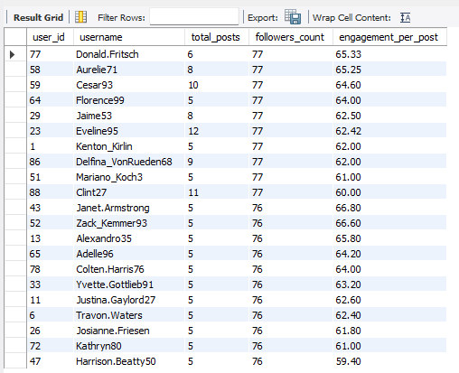

Approach:
Potential brand ambassadors were identified by analyzing a combination of influence and activity metrics:
- Number of posts (content consistency)
- Follower count (audience reach)
- Engagement per post (audience responsiveness)
Users with high follower counts and strong engagement per post, along with regular content creation, were considered strong candidates since they can both reach and influence a large audience.

Interpretation:
- Top users (e.g., Donald.Fritsch, Aurelie71, Cesar93, Florence99, Jaime53, Eveline95) show a strong balance of reach and engagement.
- Consistent posting indicates reliability and ongoing platform presence.
- High engagement suggests authentic influence and active follower communities.
- Such users are likely trusted voices within their networks, making them effective advocates.

Conclusion:
Segmenting users by behaviour enables more effective targeting and personalization. Highly engaged users can receive premium content, early feature access, or ambassador opportunities, while less active users can be targeted with re-engagement campaigns and tailored recommendations. Such data-driven segmentation improves user experience, retention, and marketing effectiveness across the platform.

- How would you approach this problem, if the objective and subjective questions weren't given?

Ans:

1. Understand the Business Context:
First, I would clarify the purpose of the analysis, such as:
- Increasing user engagement
- Improving retention
- Identifying growth opportunities
- Supporting marketing decisions
Understanding the business objective ensures that the analysis remains relevant and actionable.

2. Explore the Dataset (EDA):
I would examine the database schema and relationships among tables such as users, photos, likes, comments, follows, tags, and photo_tags.
Key exploration tasks include:
- Reviewing table structures and data types
- Checking record counts
- Identifying patterns and distributions
- Detecting missing or inconsistent data

3. Data Cleaning & Validation:
Before analysis, I would ensure data quality by:
- Handling NULL values
- Removing duplicates
- Resolving inconsistencies
- Verifying referential integrity
Reliable insights depend on clean data.

4. Define Key Metrics (KPIs):
Based on the platform context, I would define core performance metrics across major dimensions:
Engagement Metrics
- Posts per user
- Likes and comments per post
- Follower counts
- Engagement rate
Retention Metrics
- Active vs. inactive users
- Frequency of interactions
- Consistency of posting
Growth Metrics
- New user registrations
- Follower growth patterns
- Content trends

5. Perform Analytical Queries:
Using SQL operations such as joins, aggregations, window functions, and CTEs, I would analyze relationships and trends, for example:
- Identifying top influencers
- Detecting inactive users
- Finding popular hashtags
- Measuring engagement distribution

6. Segment the User Base:
Users would be grouped into meaningful segments, such as:
- Highly engaged users
- Moderate users
- Inactive users
- Influencers / brand advocates
Segmentation enables targeted strategies.

7. Derive Business Insights:
From the analysis, I would identify actionable findings, such as:
- Content types driving engagement
- Optimal posting behaviors
- Opportunities for re-engagement
- Potential brand ambassadors

8. Recommend Data-Driven Strategies:
Based on insights, I would propose solutions such as:
- Targeted marketing campaigns
- Personalized recommendations
- Incentive programs
- Content optimization

9. Visualization & Reporting:
Finally, results would be communicated through dashboards, charts, and a structured report to make insights understandable for stakeholders.

Conclusion
Even without predefined questions, a systematic analytical approach ensures that meaningful insights can be extracted from the dataset and translated into actionable business recommendations.

- Assuming there's a "User_Interactions" table tracking user engagements, how can you update the "Engagement_Type" column to change all instances of "Like" to "Heart" to align with Instagram's terminology?
Ans: Updating engagement terminology ensures consistency across the database and aligns stored data with the platform’s user interface and branding standards.
The UPDATE statement replaces all occurrences of “Like” with “Heart” in the engagement column, ensuring consistency with platform terminology.

